### **How to run MySQL Server Service for Windows 10**

1. Your MySQl is a server service which you must start before using it.
2. Press **Win+I** on your keyboard to bring up Windows Settings.
3. Using the search box, search for the "**services**."  
     
   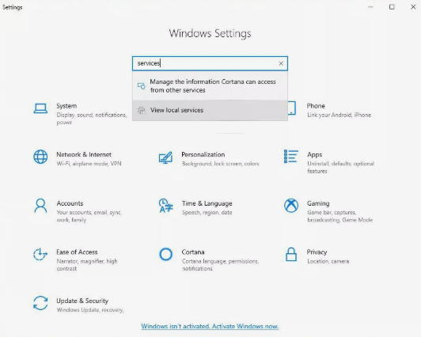
4. Select **View local services**.
5. Once the Services app launches, locate the MySQL service. It's probably something like "MySQL80.**"**Basically MySQL plus the version number, 8.0.

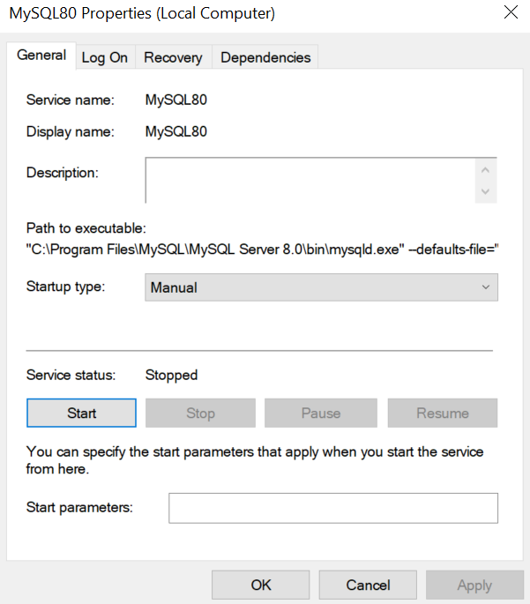

1. If the service is stopped, select **Start**. If it's already running, you can select **Restart**, **Pause**, or **Stop**. You can use this to make sure MySQL is only running when you want to use it.

### **How to run MySQL Workbench App for Windows 10**

1. The MySQL Workbench App is in your start bar, then just activate the MySQL Server icon. 

The MySQL Workbench tool is used for data modeling, SQL development, and comprehensive administration tools for server configuration, user administration, backup, and much more. We will mainly use MySQL Workbench to:

* write and test the SQL sentences you create
* design the database model

If the Icon is not there, then refer to the document C207_L01_Software Installation Guide for Windows 10, Steps 15 to 17.